APPLIED INDUSTRIAL IOT PROJECT

PROCESSING OF DAIRY PRODUCTS

AIM OF THE PROJECT:

To solve the typical problem faced by the processing of dairy products.

PROBLEM STATEMENT AND SOLUTION:

In the context of IoT (Internet of Things) and processing dairy products, several challenges and problems can be encountered. Some of the key issues include:

Data Collection and Connectivity: Dairy farms and processing facilities may be located in remote or rural areas with limited internet connectivity. Gathering real-time data from sensors and devices in such locations can be challenging. Stable and reliable data connectivity is crucial for transmitting data to central systems for analysis and decision-making.

Sensor Integration and Calibration: Integrating sensors into the dairy production process requires careful calibration and maintenance to ensure accurate measurements. Variability in temperature, humidity, and other environmental conditions can affect sensor performance, leading to inaccurate data and potentially compromised product quality.

Using IoT (Internet of Things) in dairy processing can offer several solutions to address the challenges faced in the industry. Here are some ways IoT can help resolve these problems:

Real-time Data Collection: IoT sensors can be deployed throughout the dairy processing chain to collect real-time data on temperature, humidity, pH levels, milk flow, and more. This data can be transmitted wirelessly to central monitoring systems, enabling timely decision-making and proactive interventions to optimize production processes.

Remote Monitoring and Control: IoT allows dairy farmers and processors to remotely monitor and control critical parameters in the production chain. This capability is especially valuable for dairy farms located in remote areas. Farmers can adjust equipment settings and environmental conditions from a distance, improving efficiency and reducing the need for on-site presence.

PROJECT DESIGN SPECIFICATIONS:

Designing an IoT (Internet of Things) system for the processing of dairy products involves integrating sensor technologies, data communication, and data analysis to optimize the processing, ensure quality, and enhance efficiency. Here are some key design specifications for an IoT system in dairy product processing:

* Real-time Monitoring: Implement sensors to monitor critical parameters such as temperature, humidity, pH levels, milk flow rates, and equipment status in real-time. This helps ensure that processing conditions remain within optimal ranges.

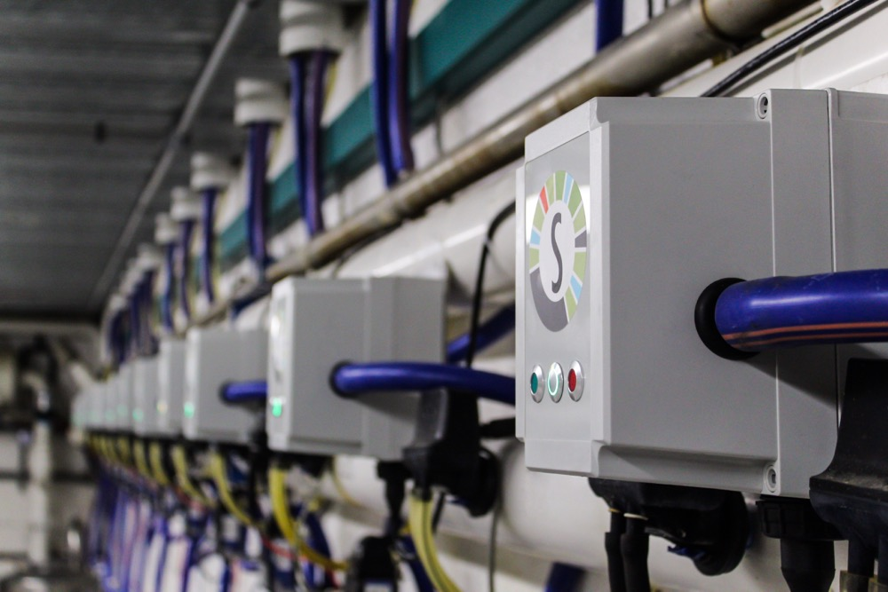

* Data Collection: Design the system to collect and aggregate data from various sensors across the processing facility. Data should be securely stored and time stamped for traceability.
* Process Automation: Develop automation mechanisms based on sensor data. For example, automatic adjustments to heating or cooling systems based on temperature readings.

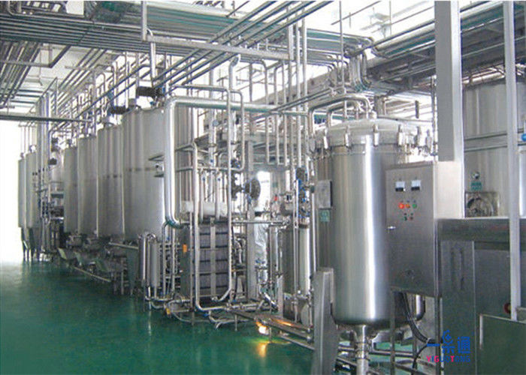

* Regulatory Compliance: Ensure that the IoT system complies with relevant food safety and processing regulations. Data logging and traceability are crucial for this aspect.
* Quality Control: Integrate sensors and algorithms to monitor the quality of raw milk and processed products. This could involve measuring fat content, protein levels, or detecting contaminants.

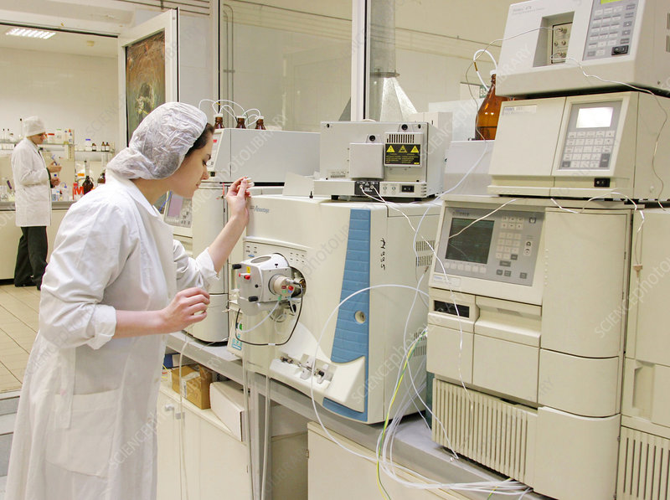

PROJECT ARCHITECTURE:

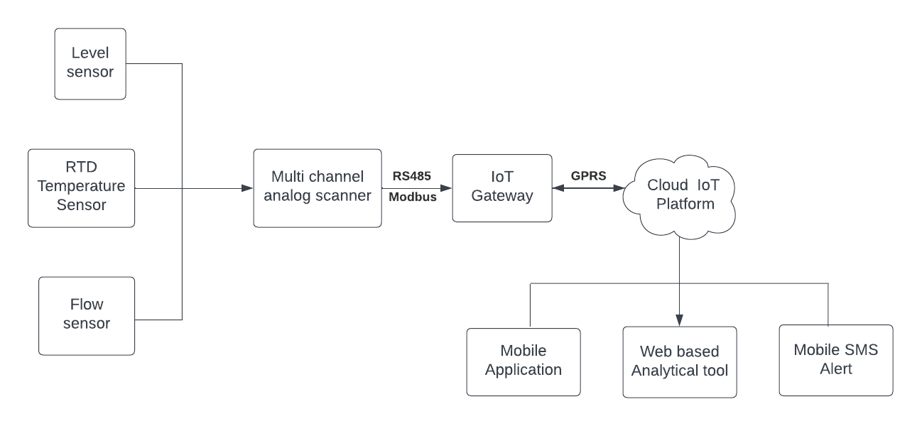

FLOW EXPLANATION:

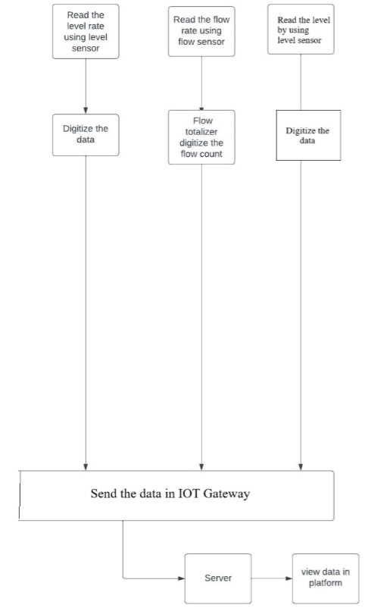

WIRING DIAGRAM:

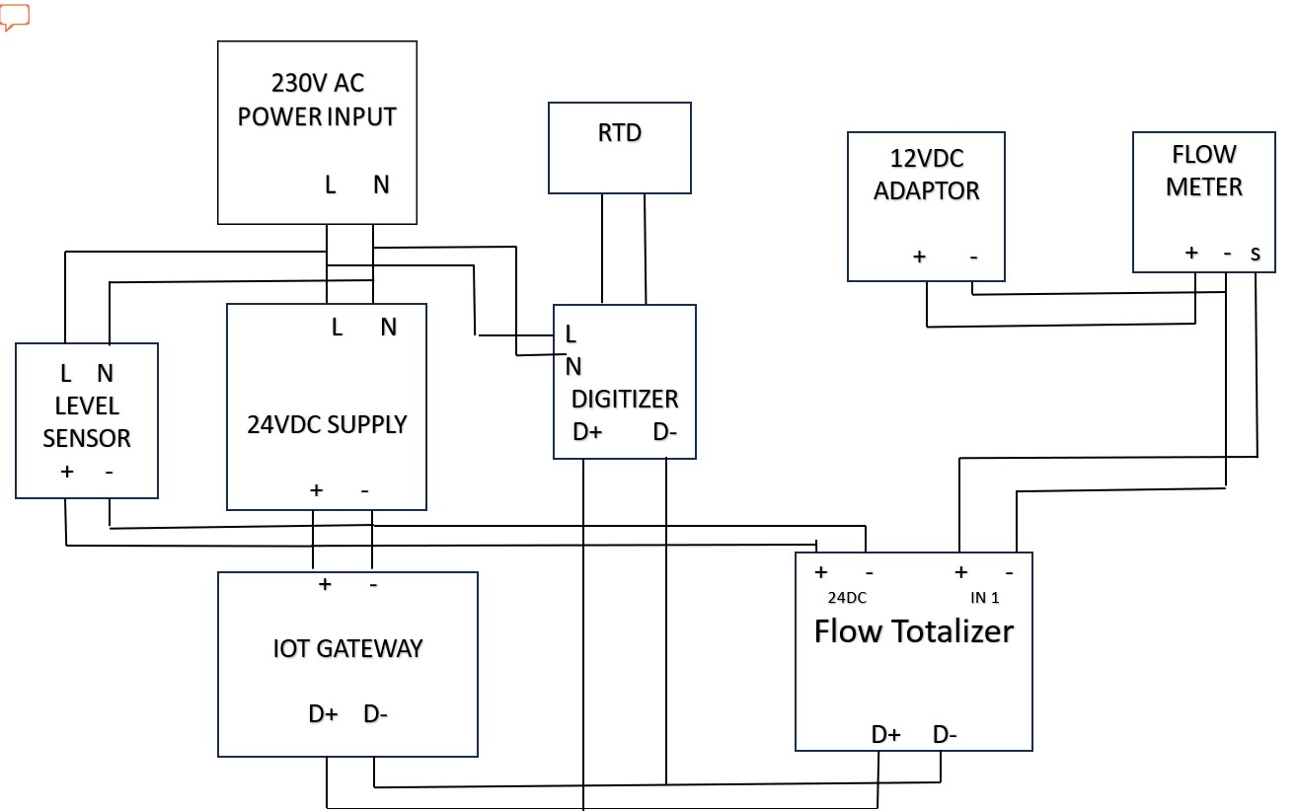

NOTE:

1. D+ D- : RS485 Modbus RTU physical connection

2. L,N: Line and Neutral for AC Power supply

3. +,- : 24VDC power terminals

COMPONENTS WORKING PRINCIPLES / FUNCTIONALITY:

The processing of dairy products involves several components, each with specific working principles and functionality to transform raw milk into finished products. Here are the key components and their roles in the dairy processing process:

* Pasteurization Unit:

Working Principle: The pasteurization unit heats the raw milk to a specific temperature for a set period, effectively killing harmful pathogens while preserving the taste and nutritional qualities.

Functionality: Ensures the safety of the dairy product by reducing the microbial load and extending its shelf life. Different pasteurization methods (e.g., High-Temperature Short-Time - HTST or Ultra-High-Temperature - UHT) can be employed based on the product.

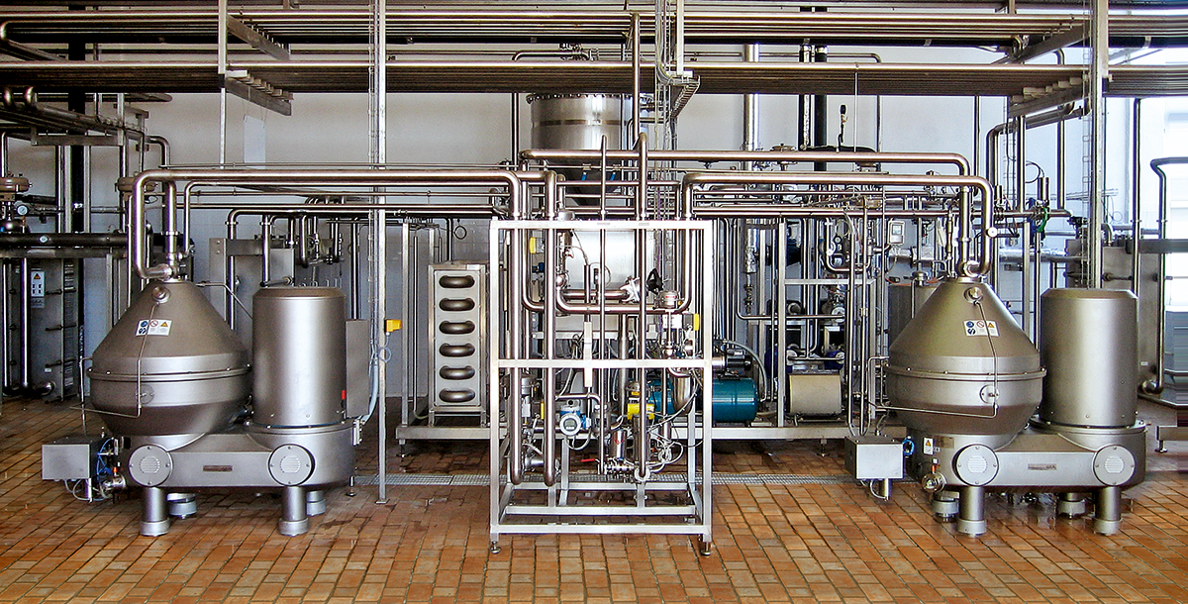

* Homogenizer:

Working Principle: Homogenization breaks down fat globules in milk under high pressure, ensuring the uniform distribution of fat particles and preventing cream separation.

Functionality: Improves the texture, taste, and appearance of products like milk, ice cream, and yogurt by creating a smooth product.

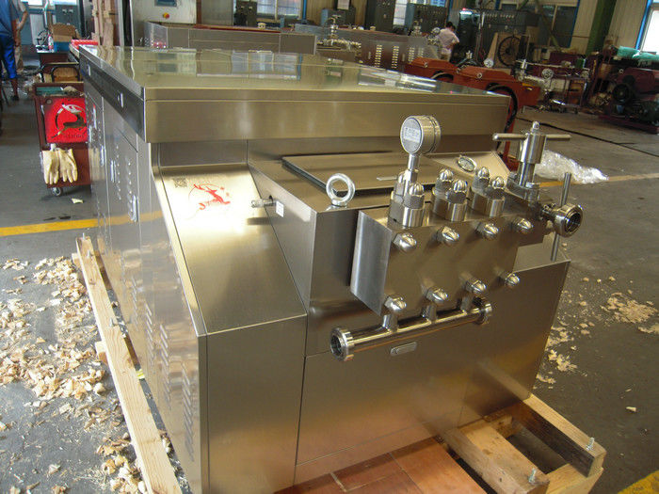

* Cultures and Enzymes:

Working Principle: Specific bacterial cultures and enzymes are added to milk for fermentation, breaking down lactose, producing lactic acid, and forming curds in cheese-making processes.

Functionality: Creates distinct flavors, textures, and characteristics in cultured dairy products like yogurt, cheese, and buttermilk.

* Filtration System:

Working Principle: Filtration is used to remove impurities, debris, and unwanted microorganisms from the raw milk or other dairy ingredients.

Functionality: Ensures product purity and quality, especially in products where cleanliness is crucial, such as cheese production.

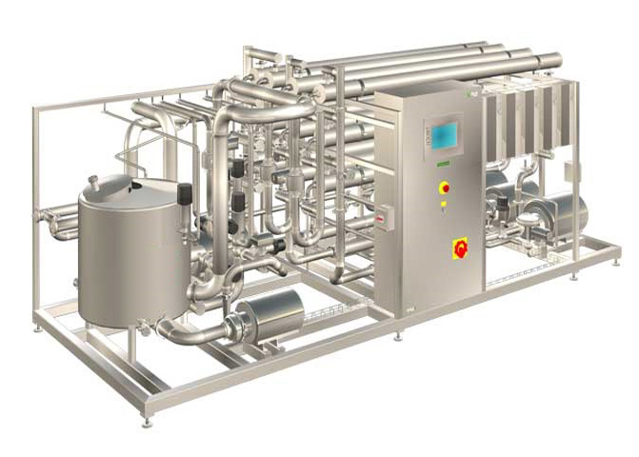

* Chilling and Cooling Systems:

Working Principle: These systems rapidly lower the temperature of the processed product to stop the growth of harmful microorganisms and preserve product quality.

Functionality: Extends the shelf life and maintains the freshness of dairy products.

* Quality Control Sensors:

Working Principle: These sensors monitor critical parameters (temperature, pH, viscosity, fat content, etc.) throughout the processing stages.

Functionality: Ensures that the product meets regulatory standards, maintains consistency, and detects any deviations that might affect the final product.